My secret Badger Wood
By Oliver Marchant
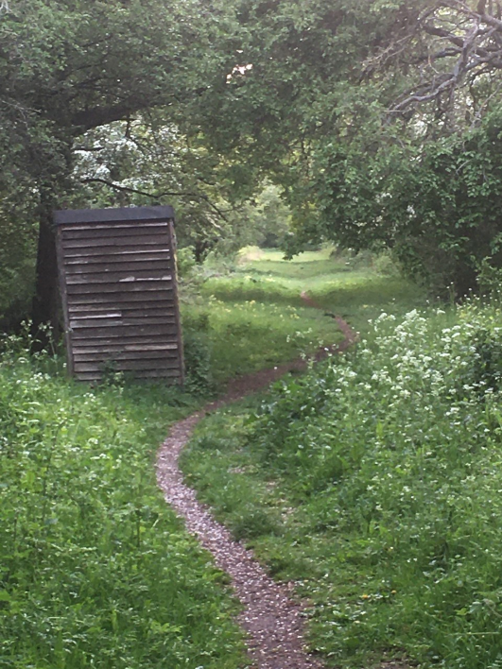
Today I walked to “Badger Wood”. The wood is so special to my family I am not going to reveal its location. All I am willing to say is it is within 4 miles of Malvern and part of a stunning wildlife reserve.

To me the walk to “Badger Wood” is just as special as the wood itself: strolling across pastures of lush green grass that ripple in the soft breeze; the meadows of wild flowers, rare orchids that clump together as if scared of the other flowers; the fields of lambs frolicking and the swooping swallows.

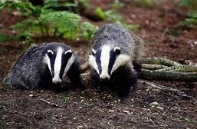
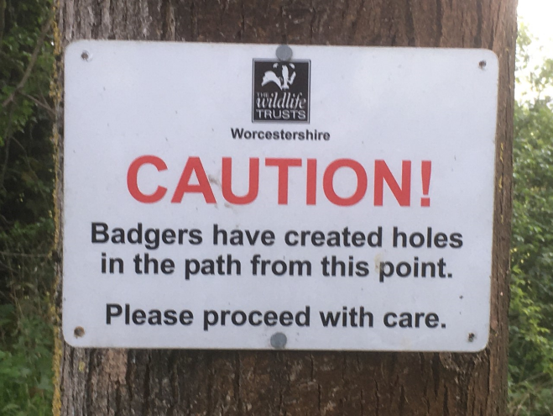
And then you step through the gate to “Badger Wood” and you enter a whole new world. The bird’s soft enchanting song sweetly floats to your ears. The humongous burrows and mounds indicate the sleeping world under your feet. Bowing bluebells and unfurling ferns are everywhere. Small snout holes reveal the feeding ground on which you stand, as you continue under the canopy the only sign of human activity is a rustic hide which stands lopsidedly. You walk on and find yourself in a clearing where an ancient apple tree stands, its branches reaching out as if to make space for its autumn bounty.

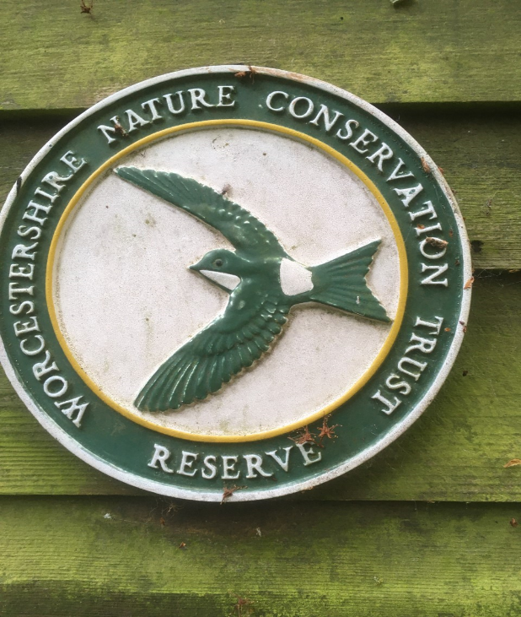
The reason the place we call “Badger Wood” is so special to our family has already been explained...but, it has become a real haven during lock down, as it is easily accessible from our home in Hanley Swan. Long may the badgers rule the quiet stretch of our “Badger Wood”. And long may they be protected.

