Malvern Civic Writing Competition – The Christmas Festival
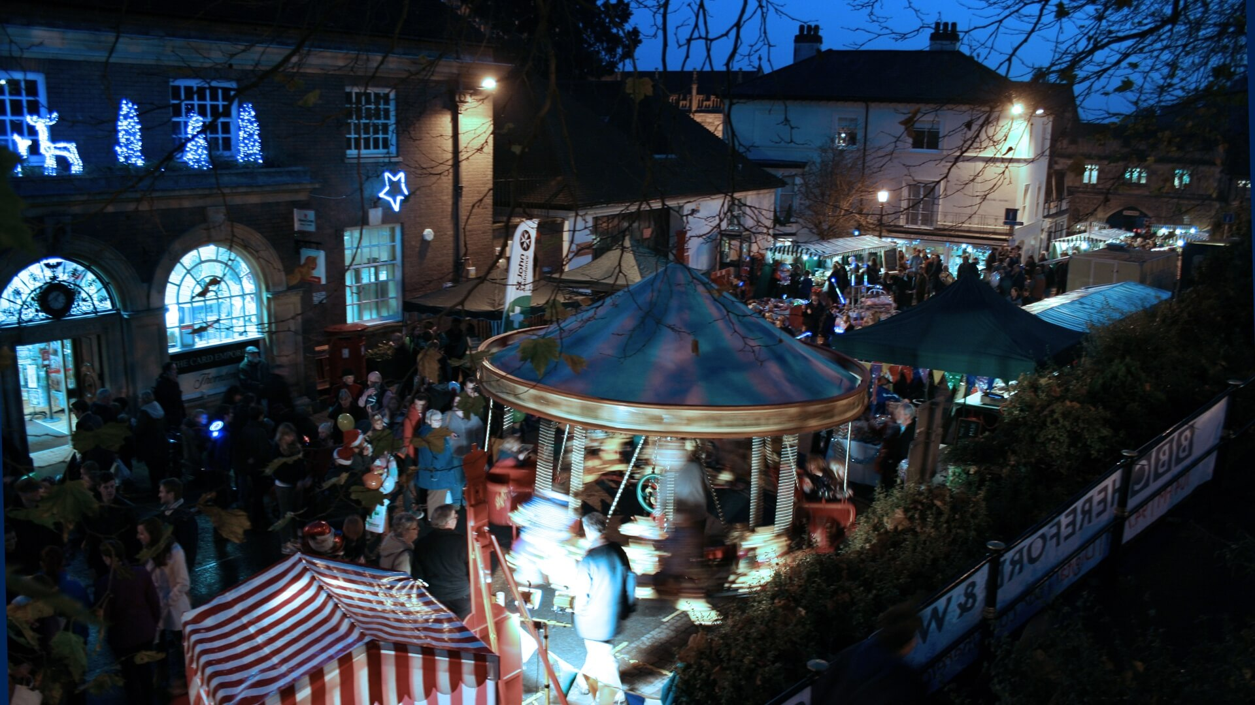
The closer it gets to the evening; the more people start to show up in Great Malvern. Every year my family and I go to the Christmas festival, and every year we love it more. The first thing you spot when you walk up the hill are the huge, twinkling lights that are hang above the main road. As you walk, your nose and cheeks begin to get rosy from the chill and the smell from the food stalls wafts through the air. The stalls always start with the food and drink – hot, fragrant mulled wine, piping cups of hot chocolate and delicious baked goods. Everyone congregates around each other like a cluster of mice trying to get to the free samples of food. The artists stalls are set up around the gorgeous, illuminated church grounds. The products range from smooth, resin jewellery; to wooden, handmade children’s toys and beautiful pieces of art that always make the perfect gift for last minute present buyers. Jolly Christmas music floods through the air and families sing as they shop.
At the top of the hill, the great, dark green Christmas tree stands - lights covering the branches - patiently waiting for the countdown to begin. Slowly, groups start making their way up to the top of the hill, chatting and singing away, awaiting the start of the magic. Everyone huddles tightly together, keeping out the icy winds. Everyone looks up as they hear the countdown begin over the speakers. “3” ...”2” …”1”! The entire street illuminates along with people’s Christmas spirit. Shortly after, the parade begins. Dancers make their way up the hill, followed by little children from the primary schools clinging onto their parents and their brightly coloured, glowing lanterns, which shine brightly (lighting the street even more). People cheer as Christmas Joy fills the town.

Keira Layton, 14
Hanley Castle High School, Year 9.

