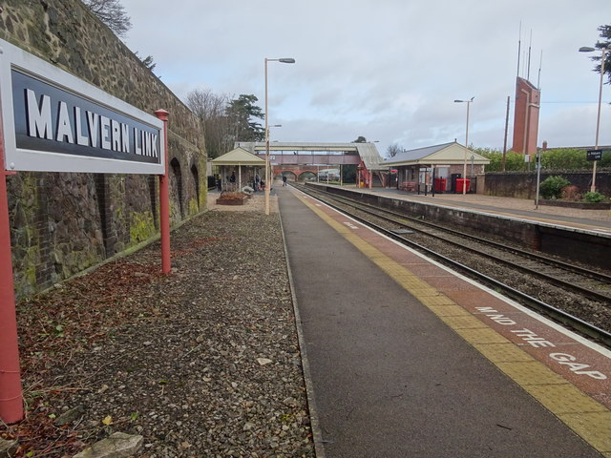
Literacy Competition 2020
I’ve decided to go to the Malvern Link Train Station!
I still remember some joyful memories spent here before I even went to primary school, with parents, grandparents, uncles and aunties, friends and many others, some who are not with us anymore… As a child, I always used to see the train station as a pathway to new places, adventure and exploration! It would excite me every time we got near it, regardless if we were going to the station or not. However, people used to mistreat the station, it was used as a hangout, vandalised and used as a dump for cigarettes, drugs and other disturbing things. It was upsetting to see whilst growing up.
Yet, now it looks so shiny ever since it got refurbished in 2014. The bridge went from damaged to decorative, the platform went from splattered to sparkling and the whole station had a vintage feel to it and it felt welcoming once again. It looks interesting, professional it added colours which brightened up the place. I’m glad they made these changes; I believe the station deserved this.
My favourite memory of this place is going on a trip with my primary school, we discovered about architecture and how elegant Great Malvern Station looked with its colours and patterns. When we returned to Malvern Link, the sun finally came out after it had rained all day.
I don’t usually visit the station anymore, since we moved house to Upton before I went up to high school and, of course, the current state of the world means we haven’t been anywhere at all. I wonder how it has changed, if changed at all. So, that’s the place I would visit as it is a fond childhood memory of mine.

Jamie M- Year 9 -29/04/20
Hanley Competition

